P6.1)

syms A b ;

b=[1;1];

A=[1 1;(1+sqrt(sym(5)))/2 (1-sqrt(sym(5)))/2];

sol=simplify(A\b)

c1= 5^(1/2)/10 + 1/2

c2= 1/2 - 5^(1/2)/10

n=25

fn=c1\*((1+sqrt(5))/2)^n+c2\*((1-sqrt(5))/2)^n

sol = 5^(1/2)/10 + 1/2

1/2 - 5^(1/2)/10

fn = 121393

P6.3)

syms lh;

sgm=(-2-+sqrt(1+2\*lh))/(2\*lh-3);

tr=taylor(exp(lh),lh,'Order', 6)

err = taylor(exp(lh),lh,'Order', 6)-taylor(sgm, lh, 'Order', 6)

tr =lh^5/120 + lh^4/24 + lh^3/6 + lh^2/2 + lh + 1

err =- (11\*lh^5)/30 - lh^4/12 - lh^3/3

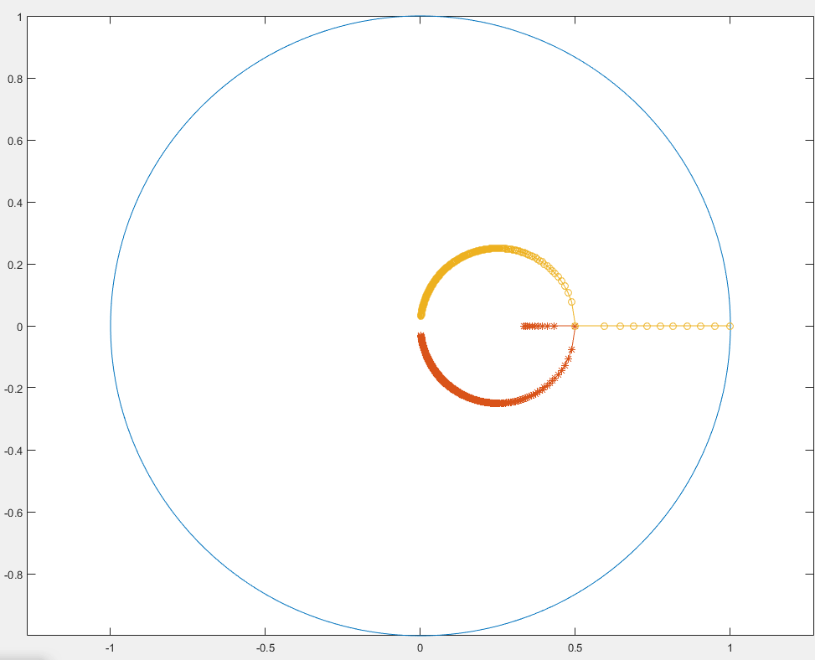(d)

x=linspace(0,8,2000);

plot(sin(x),cos(x)); % Draw the circle

hold on;

lh=0:-0.05:-500; % lamda\*h from[0,-500]

s1=(-2+sqrt(2.\*lh+1))./(2.\*lh-3);

s2=(-2-sqrt(2.\*lh+1))./(2.\*lh-3);

plot(s1,'-\*')

plot(s2,'-o')

axis equal;

hold off;

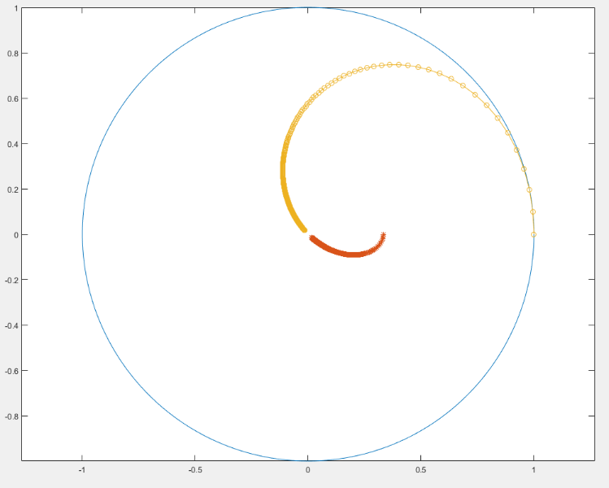x=linspace(0,8,2000);

plot(sin(x),cos(x));

hold on;

wh=(0:0.1:10000);

lh=wh\*i;

s1=(-2+sqrt(2.\*lh+1))./(2.\*lh-3);

s2=(-2-sqrt(2.\*lh+1))./(2.\*lh-3);

plot(s1,'-\*')

plot(s2,'-o')

axis equal;

hold off;

P6.6)

syms E l h l ;

P=[E^(1/3) 0 -(1+h\*l/3) ;-h\*l/2\*E^(1/3)...

E^0.5 -1;0 -h\*l\*E^0.5 E-1];

B=simplify(det(P));

Q=P;

Q(:,3)=[h/3;h/2\*exp(muh)^(1/3);h\*exp(muh)^(1/2)];

eqn=B==0;

sol=solve(eqn,E)

Q=P;

Q(:,3)=[h/3;h/2\*E^(1/3);h\*E^(1/2)];

ratio=simplify(det(Q)/det(P))

sol = 0

(h^3\*l^3)/6 + (h^2\*l^2)/2 + h\*l + 1

ratio =-(h\*(6\*E^(1/2) + h^2\*l^2 + 3\*E^(1/3)\*h\*l))/(h^3\*l^3 + 3\*h^2\*l^2 + 6\*h\*l - 6\*E + 6)

syms lh;

expression=exp(lh)-1-lh-lh^2/2-1/6\*lh^3;

taylor(expression,lh, 'Order', 8)

ans =lh^7/5040 + lh^6/720 + lh^5/120 + lh^4/24

syms E l muh mu h;

P=[exp(muh)^(1/3) 0 -(1+h\*l/3) ;-h\*l/2\*exp(muh)^(1/3)...

exp(muh)^0.5 -1;0 -h\*l\*exp(muh)^0.5 exp(muh)-1];

B=simplify(det(P));

Q=P;

Q(:,3)=[h/3;h/2\*exp(muh)^(1/3);h\*exp(muh)^(1/2)];

eru=det(Q)-det(P)/(mu-l)

taylor(eru,muh, 'Order', 1)

eru =h\*exp(muh)^(4/3) - (exp(muh)^(5/6) - exp(muh)^(11/6) + (h^2\*l^2\*exp(muh)^(5/6))/2 + (h^3\*l^3\*exp(muh)^(5/6))/6 + h\*l\*exp(muh)^(5/6))/(l - mu) + (h^3\*l^2\*exp(muh)^(5/6))/6 + (h^2\*l\*exp(muh)^(7/6))/2

ans =h + (h^2\*l)/2 - ((h^3\*l^3)/6 + (h^2\*l^2)/2 + h\*l)/(l - mu) + (h^3\*l^2)/6

P(7.4)

A=[-1 -1 -1 -1;0 1 2 3;0 -0.5 -2 -4.5;0 1/6 4/3 27/6];

b=[-1;-0.5;-1/6;-1/24];

ss= A\b;